

**About us**

Founded in 2018, we are the world’s leading managed cloud kitchen platform that partners with restaurants to expand their delivery reach.

We provide restaurants with access to state-of-the-art infrastructure at a minimal capital expenditure, expertly-trained staff, and industry focused technology.

Our platform is unique. We’ve developed an in-house suite of applications (collectively known as a smart kitchen operating system - “SKOS”) which optimize all aspects of kitchen operations in real time to maximize efficiency and increase utilization.   
We also cater to the entire customer experience journey - from the call center to delivery, allowing restaurant owners to focus on running their dine-in space, marketing and menu development.

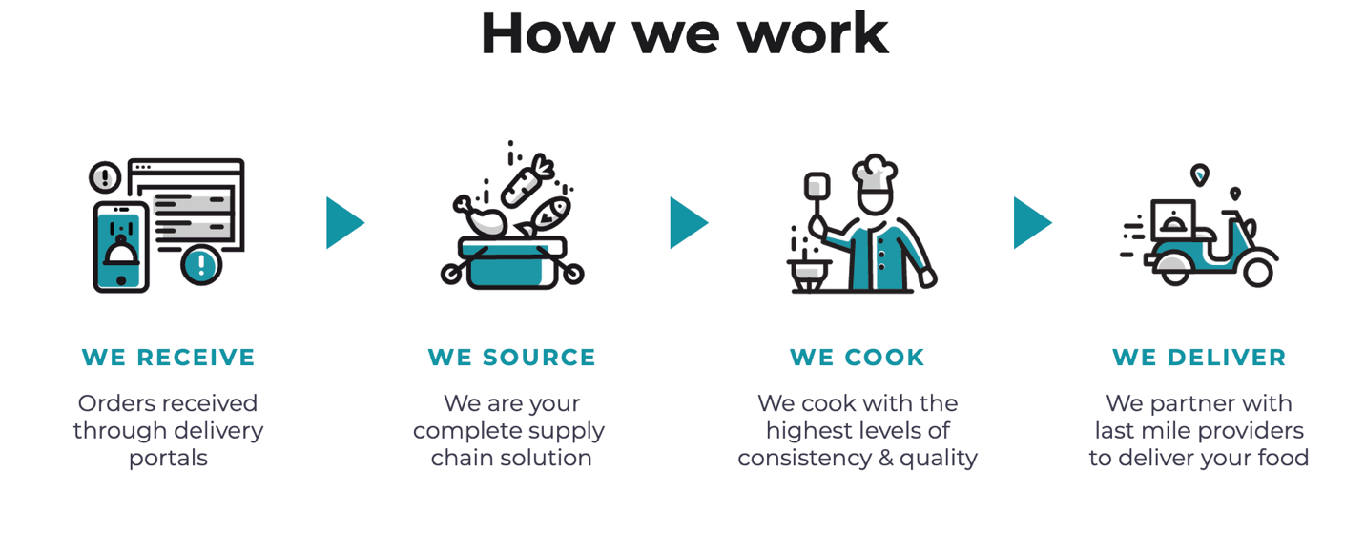

**Our apps**

1. **Restfull API:** Main portal where our clients send their orders.
2. **Database:** Service to manage our databases.
3. **Kitopi Sales & Partners App:** Web application to manage our clients and orders.
4. **Deliver IOS/ANDROID app:** Mobile application where our delivery people register and track orders.